CIS 8395 - Big Data Analytics Experience

(Fall 2022) Final Project Paper

December 11th, 2022

**Topic: Product Based Recommendation System**



## Submitted by: Full Stack Crew

Angeline Vaishali Yetukuri

Swati Hiremath

Sukumar Reddy Kottala

Gopi Sandeep Guntuku

Table of Contents

MISSION STATEMENT: 3

ABOUT THE COMPANY: 3

BUSINESS PROBLEM: 4

PROPOSED SOLUTION: 4

ARCHITECTURE: 4

DATA SOURCE: 5

ETL PROCESS: 7

EXTRACT: 7

TRANSFORM: 7

LOAD: 7

DATA SOURCING: 7

DATASET SIZE: 8

EXTRACT: 8

COMBINING DATA: 9

TRANSFORM: 9

DATA CLEANING: 9

LOAD: 11

DATA STORAGE: 11

DATA LINEAGE: 13

EXPLORATORY DATA ANALYSIS: 13

TABLEAU: 14

IMAGE CLASSIFICATION AND RECOMMENDATIONS: 15

IMAGE CLASSIFICATION: 15

RECOMMENDATIONS: 16

TEXT BASED RECOMMENDATION SYSTEM: 17

IMAGE BASED RECOMMENDATION SYSTEM: 18

KEY PERFORMANCE INDICATORS (KPI): 26

CHALLENGES: 27

FUTURE WORK: 27

REFERENCES: 27

## 

## MISSION STATEMENT:

"At eBay, our mission is to provide a global online marketplace where practically anyone can trade practically anything, enabling economic opportunity around the world."



## ABOUT THE COMPANY:

An American based global e-commerce company eBay was established in 1995 in San Jose, California. eBay was launched by Pierre Omidyar and was initially known as AuctionWeb. In 1997, the company renamed itself to eBay and acquired $6.7 million financing from Benchmark Capital. The organization had an international footprint in the early 2008 with over 15000 employees, hundreds of millions of registered users, and revenues close to $7.7 billion. It was one of the pioneering companies to create and market an online marketplace that brought together buyers and sellers of products and services. Since eBay is a marketplace which connects consumers, users can both facilitate transactions and sell various goods to other users. On the website of eBay, there is a feedback system which permits buyers to evaluate sellers on transactions which also gives users an opportunity to interact with each other. The company relies on its customers to self-regulate the trading community. Online retailers can also use eBay as sales channels. Consumers can search for different products from their nearby regions by entering zip codes on eBay since it is accessible throughout many countries. The most expensive item sold on eBay is a Yacht.

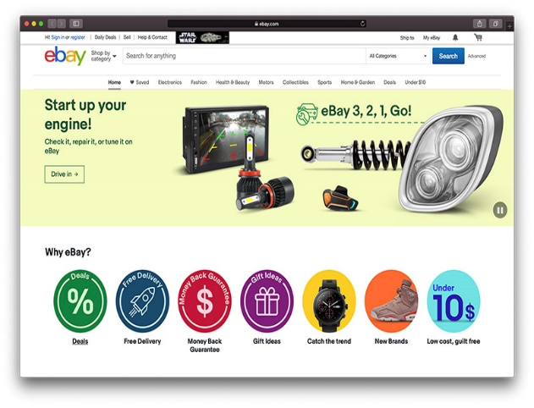

## BUSINESS PROBLEM:

In this era of online shopping, it has become very easy for people to browse around different ecommerce websites or mobile applications to purchase their desired products. It gets all mixed up when a customer must decide what they want to purchase as there is an enormous collection of products in the real world.

## PROPOSED SOLUTION:

To clear up this confusion, recommendation system has been introduced. By implementing this system whenever, a customer searches for some product he/she will be able getting suggestions of similar products. Due to this, it will be easier for the customer to look for similar products and will be able choose. The goal is to create a proactive online shopping engine that imports an image as an input, identifies the image, and suggests identical products from the catalog.

## 

## ARCHITECTURE:

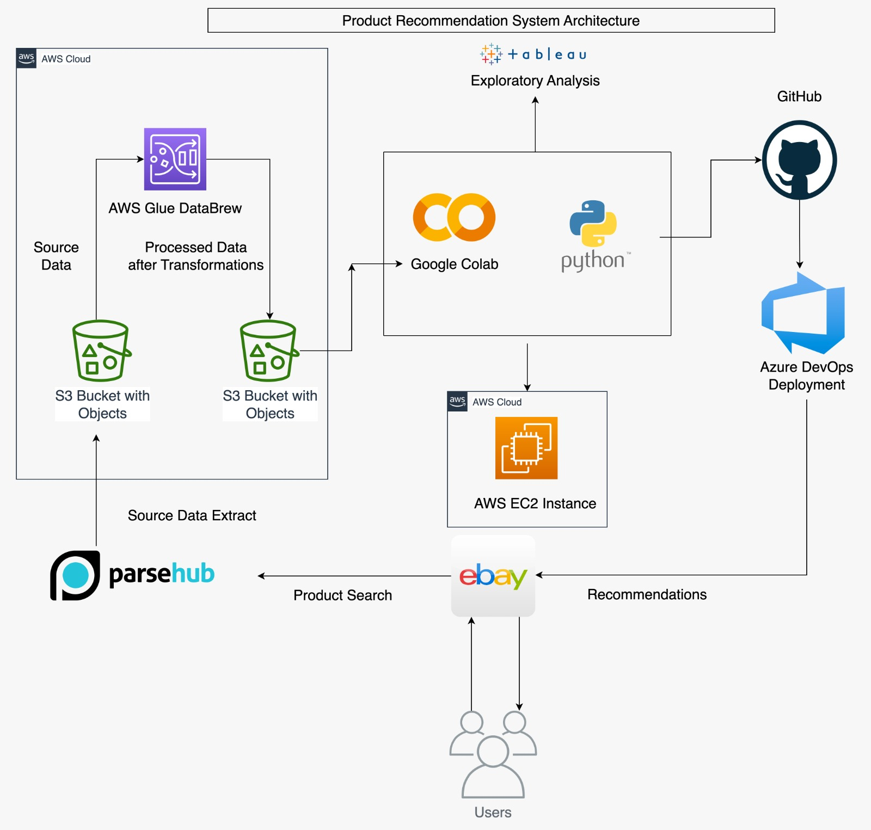

Above is the architecture design for the Product based recommendation system, where initially we are extracting the data from eBay website using Parsehub tool. The source data is stored in AWS S3 buckers and sent to AWS Glue DataBrew for cleaning the data. Using AWS Glue, the data is transformed and sent to S3 buckets again. We planned to integrate AWS and Google Colab where the Python Code for Data modeling is run and sent to AWS EC2 instance. But due to pricing concerns for Deep Learning instances, the code will be uploaded to GitHub and deployed through Azure DevOps by building a pipeline and the recommendations are generated.

## DATA SOURCE:

**ParseHub:**

ParseHub is a user-friendly and powerful visual data extraction tool. In general, data extraction can be difficult and too tedious. ParseHub makes it easy for any person to select, structure and modify elements from a website. It can also handle interactive maps, infinite scrolling, authentication, dropdowns with ease. Here are few features of ParseHub which makes it different from other web scrapping tools:

* **Easy quick select feature:** To extract the information from a webpage, one must simply point and click on it. ParseHub will automatically guess and identify the similar data.
* **Flexible and powerful:** ParseHub has a relationship engine which can identify the patterns. One can also manipulate text by using CSS selectors and edit element attributes.
* **Seamless navigation between pages:** Websites with pagination and thousands of linked pages can be handled with ease. Without having to manually type a ton of urls, you may create a unique set of instructions for each page, link sites together with just one click, or redirect to a whole different url if you’d like.
* **ParseHub API:** Easily call your data and build products powered by ParseHub. You can also download data in CSV or JSON format.

## Steps to extract image data from a website:

## 1) Creating a Project:

* + 1. In ParseHub, click on “New Project” and enter the URL from the Amazon website that we will be scraping.
    2. The webpage will now render in ParseHub, and you will be able to choose the images you want to scrape.

## Select Images to Scrape:

* + 1. Begin by selecting the first image from the search results. It will then turn green, meaning it has been selected to be scrapped.
    2. The rest of the images in the search results page will then turn yellow. Click on the second image to select all the images in the page. They will all turn green, which means they have been selected to be extracted.

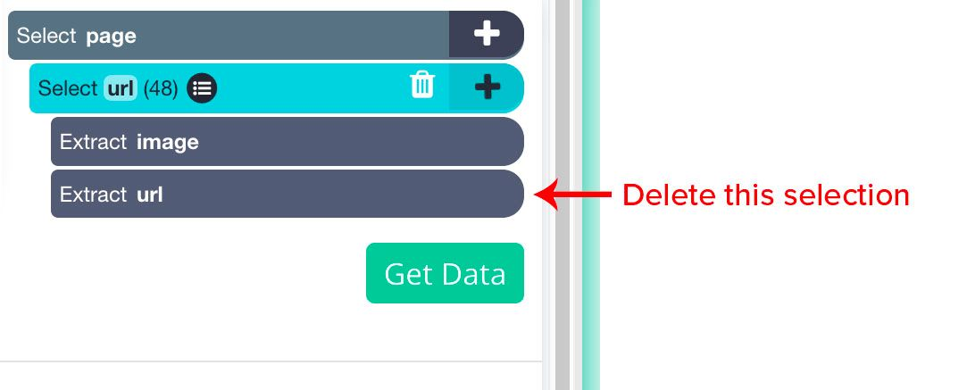

* + 1. Since these images also act as links to the product pages, ParseHub is

extracting both the image URL and the link it is pointing to (product page). As a result, we will delete the URL selection from the left sidebar and only keep the image selection.

* + 1. Now ParseHub will scrape every image URL for the first page of results.

## 3) Pagination:

* + 1. Click on the PLUS(+) sign next to the **page** selection and use the select command.

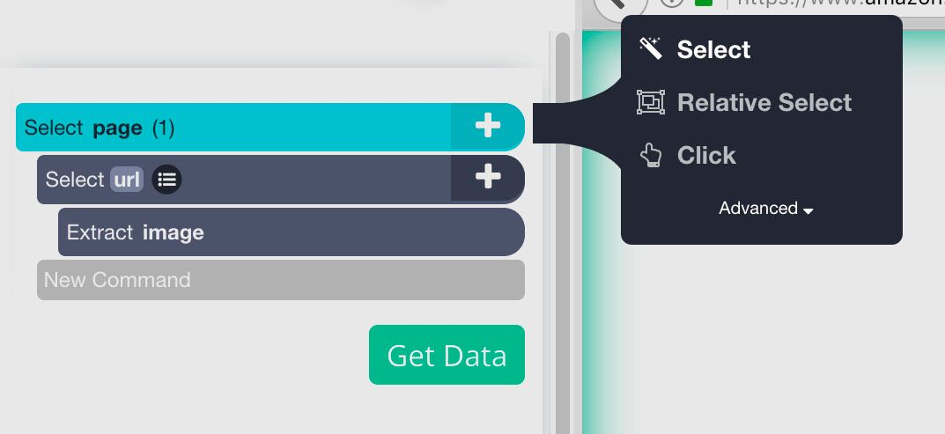

* + 1. Then click on the “Next” button and the bottom of the search results page.
    2. By default, ParseHub will extract the link from the Next button. So, we will click on the icon next to the “Next” selection and remove the two items under it.

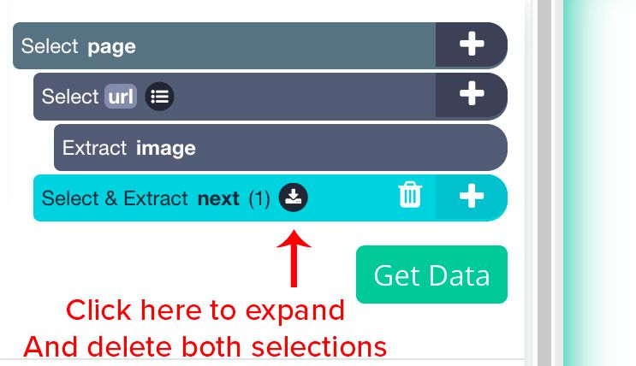

* + 1. We’ll then use the PLUS(+) sign next to the “next” selection and use the “click” command.
    2. A window will pop up asking if this is a Next Page link. Click “Yes” and enter the number of times you’d like this cycle to repeat. For this example, we will do it 5 times.

## 4) Scrape and Export Data:

* + 1. Click on the “Get Data” button on the left sidebar.
    2. Here you can select when to run your scrape. Although we always advise testing your scrape runs before running a full scrape, we’ll just run the scrape right now for this example.
    3. Now ParseHub will scrape the image URL’s you’ve selected. You can either wait on this screen or leave ParseHub, you will be notified once your scrape is complete. This process took less than 1 minute in this case.
    4. Once your data is ready to download, click on the CSV/Excel button. Now you can save and rename your file.

## ETL PROCESS:

## EXTRACT:

The first phase in ETL is extraction. Before data can be moved to its destination it should be extracted from its source. In this step, unstructured and structured data is imported and consolidated into a single repository. Volumes of data can be extracted from a wide range of sources such as cloud, on-premises, surveys, marketing applications etc.

In this project, the data is extracted using ParseHub and the real time data is downloaded in CSV format and stored in AWS S3 bucket.

## TRANSFORM:

In this phase of the ETL process rules and regulations can be applied that ensure data quality and accessibility. This step is considered as the most important part of the ETL process as it improves data integrity. The process of transformation is comprised of several sub-processes like Cleansing, Standardization, Deduplication, Verification and Sorting.

In this project, the source data is cleaned and transformed using AWS Glue Data Brew and AWS Glue ETL Tool to check Data Quality, create Data Catalog and Data Lineage.

## LOAD:

The final step in ETL process is to load the newly transformed data into a destination like data lake or data warehouse.

In this project, the transformed or processed data is loaded into AWS S3 bucket (Data Lake).

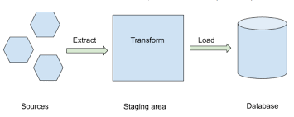

## DATA SOURCING:

Data sourcing is done by using ParseHub e-commerce web scrapping tool. The dataset includes the following features:

* product_name: Describes the name of the product available on eBay
* product_image: Images of the products available on eBay to incorporate recommendation engine
* product_image_url: The URL for the images scrapped from eBay website.
* product_price: The price of the products available on eBay
* product_reviews: Customer reviews for the products
* output: Categories of the product (Bag, Watch, Shoe, Shirt, pants, earphone, ring, anklet, necklace, laptop, phone)

## 

## DATASET SIZE:

More than 10000+ products(rows) are extracted from the eBay website.

## EXTRACT:

## 1. Data Quality:

Data quality plays an important role while building an extract, transform, and load (ETL) pipeline for sending data to downstream analytical applications and machine learning (ML) models. The analogy “garbage in, garbage out” is apt at describing why it’s important to filter out bad data before further processing. Continuously monitoring data quality and comparing it with predefined target metrics helps you comply with your governance frameworks.

## 2. Format:

We have used ParseHub to extract data from eBay website for different product. Here ParseHub is returning the data in csv format which is structured and can be easily read by user.

## 3. High Availability:

We have scrapped data from eBay website. Data on eBay website is available throughout. Once the data is extracted, we are storing the data in AWS S3 storage.

## 4. Fallback:

Critical failures prevent a service from producing useful results. For example, in an ecommerce website like eBay, if the product information fails to be scrapped from the website, Fallback decision like whether the information of similar product should be used or to give a price based on the quality will be taken.

## 5. Schedule:

Data from ParseHub can be extracted as frequently as needed that is up to every minute. Steps to schedule data extraction in ParseHub:

Step 1: Select the project.

Step 2: Click on “**Get Data**” option inside the project.

Step3: Click “**Schedule**” and select a preferred option.

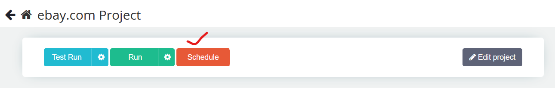

## 6. Change Process:

Data is frequently monitored to capture the change and altered accordingly to ensure that the data in the systems stay in sync. The data extracted from ParseHub is downloaded in CSV format and the same format is maintained throughout.

## COMBINING DATA:

The raw data obtained for various categories is joined together based on deterministic match. That is, the product information for all the categories is joined based on product information like name, price etc.

A columnar or C-store join is used to combine the raw data.

## TRANSFORM:

After the data has been loaded into S3, **AWS Glue DataBrew** is used to transform the data.

## DATA CLEANING:

AWS Glue DataBrew can be used to clean and transform the data. It has options like Filter, Missing values, Duplicate rows etc. Quality rules can also be written using AWS Glue DataBrew.

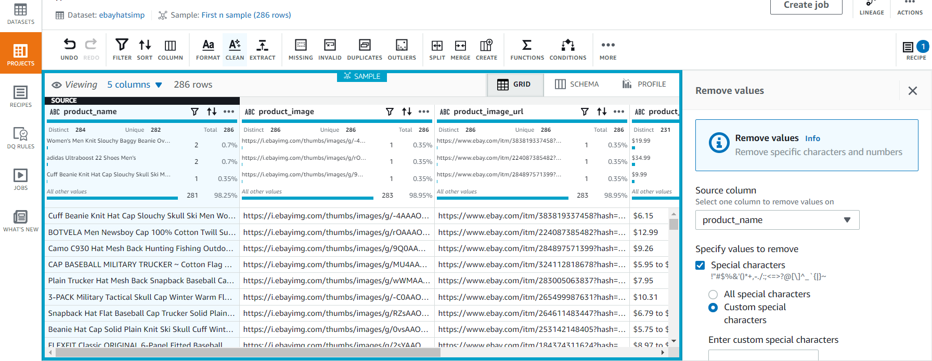

## 1. Clean:

This is the most important step of Data pre-processing. The dataset had certain special characters and punctuations since the source data has been scrapped from eBay website. These special characters are removed using the clean option.

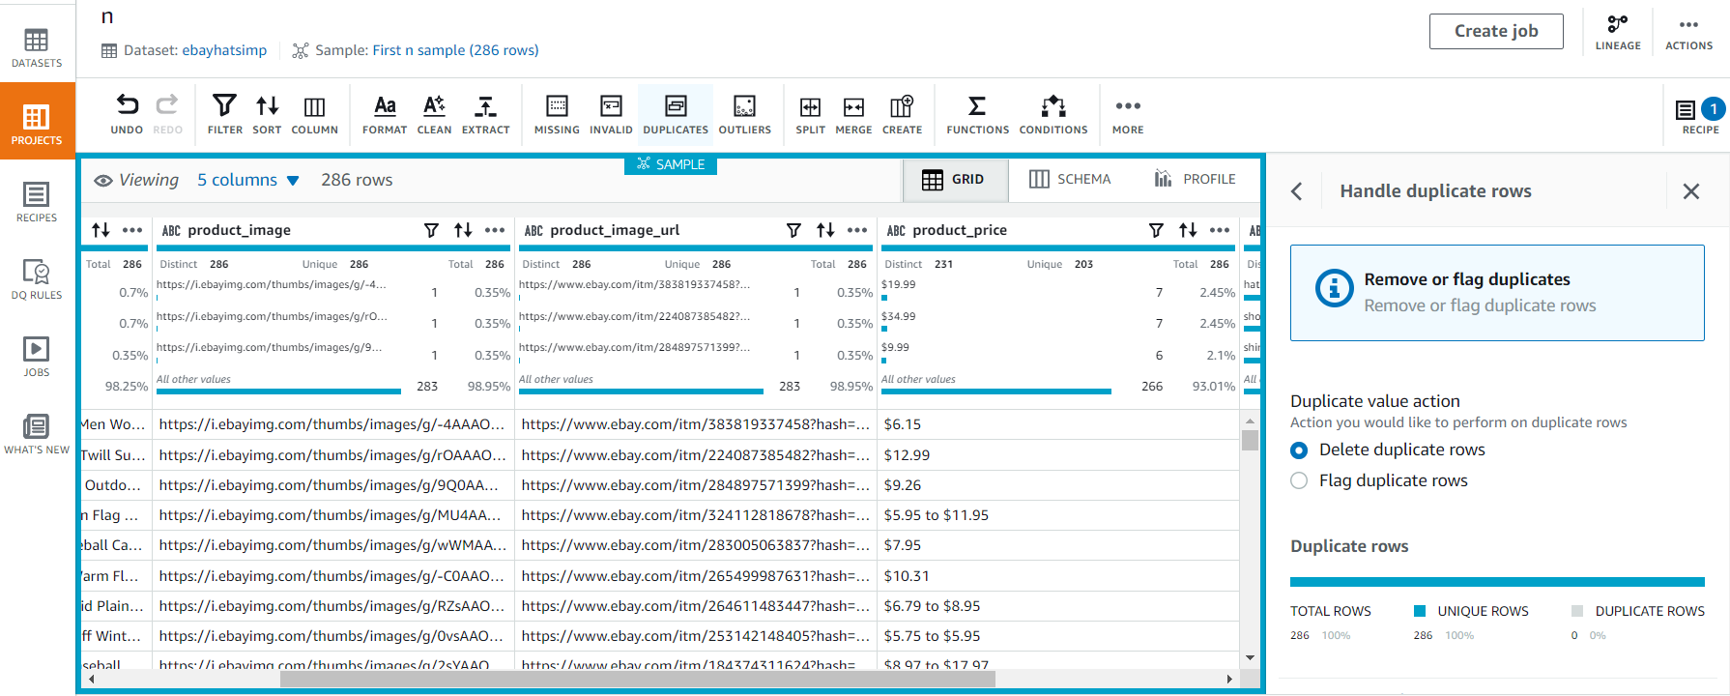

Checking for duplicate columns using AWS DataBrew.

## 2. Conformity:

Data conformity means that the data values of the same attributes must be represented in a uniform format and data types. By creating ETL job rule, the conformity of the data is verified by checking whether the datatype of each column attribute is a string.

Formatted entries of column product_name to sentence case.

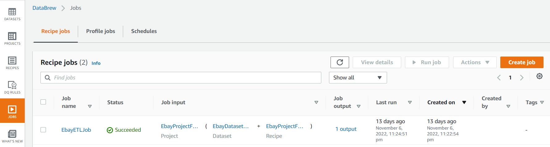

## 3. Integrity:

Data Integrity is important to maintain the reliability and trustworthiness of data throughout the lifecycle. Product_image_url is a child record of product_image. The child records have all the entries and there are no orphaned records in the dataset. The Integrity of the dataset is checked using the Filter option in AWS Glue DataBrew.

## 4. Completeness:

The completeness of the dataset is evaluated by checking the missing values. The dataset is complete even if optional data like ratings column is missing.

## 

## 5. Accuracy:

The accuracy percentage of the dataset is obtained by using AWS Athena and AWS QuickSight. The accuracy of the dataset is 97.8%.

## 6. Consistency:

Data consistency refers to the process of keeping the information uniform as it moves across the network and between various applications on a computer.

The source data is consistent with the processed data that is it is CSV format throughout the transformation.

## LOAD:

The transformed data is loaded back into S3 Buckets to be utilized by the recommendation system.

## DATA STORAGE:

The data extracted is stored in AWS Simple Storage Service (S3) bucket by specifying a globally unique bucket name which is an easy to use object storage. Amazon S3 is the best place to build a Data Lake because of its unmatched durability, scalability and availability.

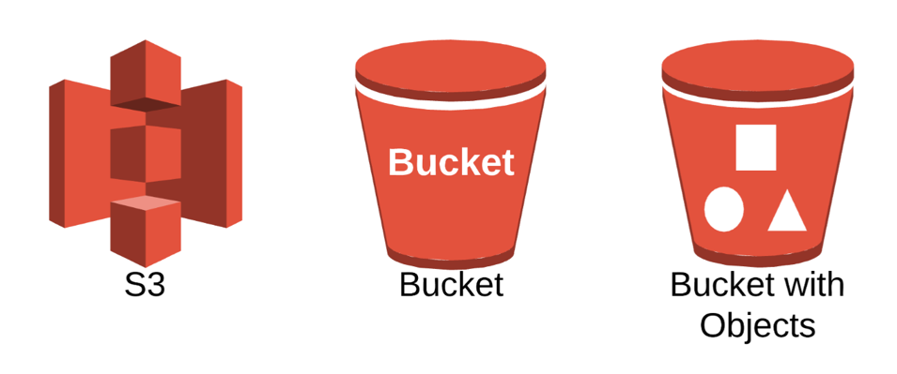

Following are the steps to create AWS S3 Bucket to store data:

**Step 1:** Navigate to S3.

In the AWS console, search for S3 under Services.

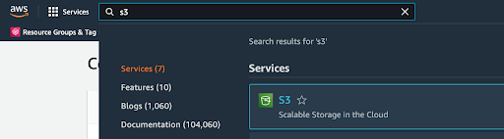

**Step 2:** Create an S3 bucket.

By clicking on the “Create Bucket”. Choose a name for the bucket which should be unique, and the name can’t have spaces or uppercase letters. And then set the configuration.

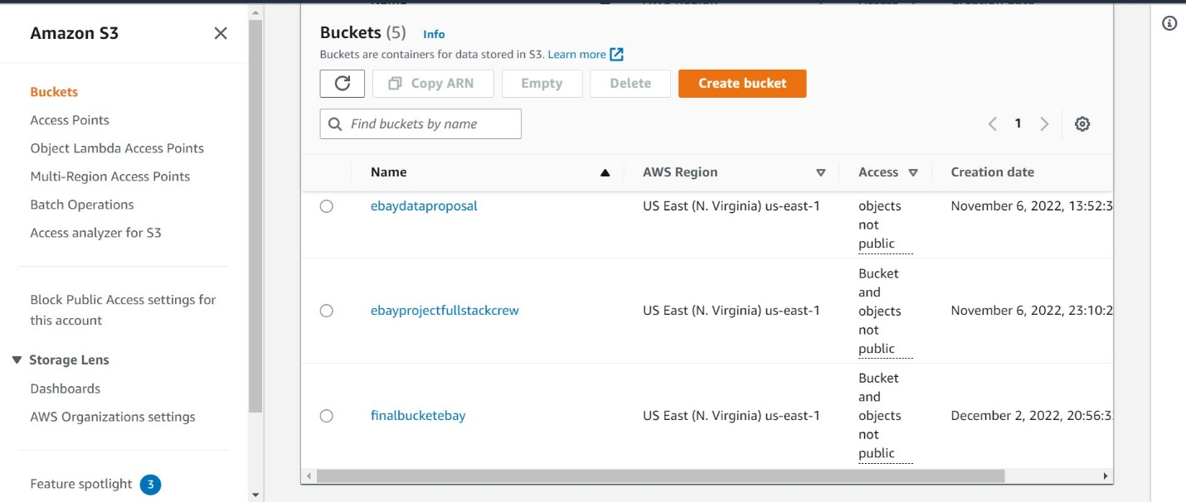

**Step 3:** Create an Object.

Next step is to create objects in S3 bucket. These objects are entities stored in S3. Later, we can click on “Upload” option to upload files that are necessary.

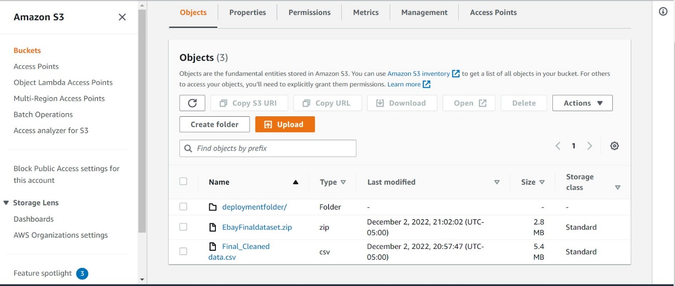

**Step 4:** Bucket Versioning.

Versioning serves to protect, retrieve, and restore each version from each object recorded in an S3 bucket.



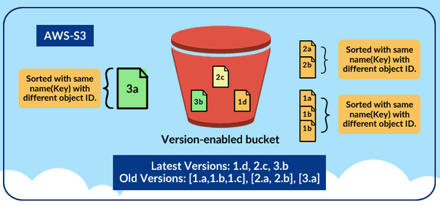

## DATA LINEAGE:

Using AWS Data Lineage, a visual representation of the overall flow of data can be obtained. It provides a look at how the data is manipulated via the ETL process.

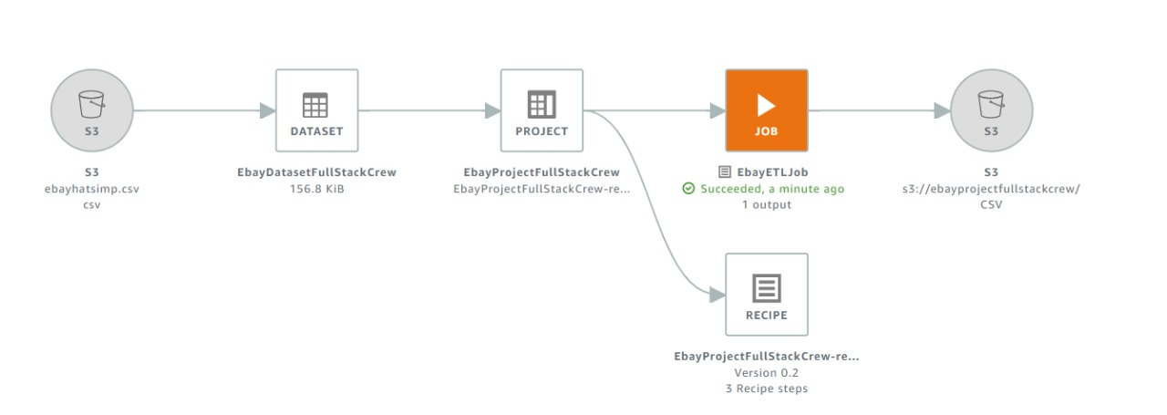

## EXPLORATORY DATA ANALYSIS:

## 1. Preprocessing Data:

The data is scraped directly from eBay website using parse hub. Once the data is scraped and stored in excel, the following steps were performed:

* The duplicate rows were removed
* The 5 CSV files are merged

We also observed that there are many null values for Product price, we will replace the brand null values to "Not given" and the rest of the null values to 0 and the price is wrongly classified as object, we will change it to float.

## 2. Visualization:

The images were saved in the csv file as a link, for that a function is created which extracts the images from the link and then stored in arrays. Then we will do the Bi-variative analysis and visualization for product price and product rating.

We also used the word cloud Python library to create word clouds of the words in the title of each of the product type. In word cloud, the relationship between word frequency and font size is linear (Frequency of word ∝ Size of text). When a word is repeated, the text is larger.

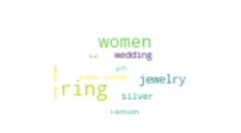 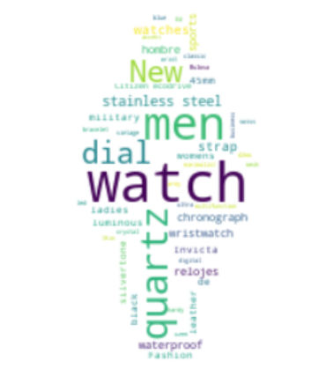 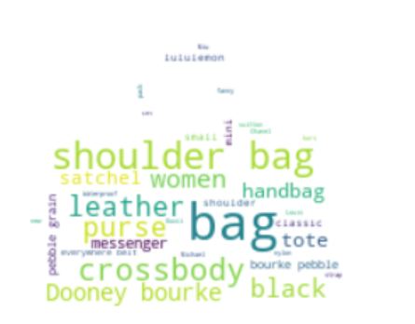

## TABLEAU:

## As the extracted dataset has five columns (one numerical column) a small dashboard has been created with three different visualizations. The dataset was connected to Tableau and new sheet was created. Three visualizations based on category, product price and product name are obtained.

## 1. A bar graph has been plotted to find the average product price based on category as shown below.

## 2. A bubble plot has been created to find the product name with its price.

## 3. Lastly, a bubble plot has been created to find the sum of product price based on category.

## IMAGE CLASSIFICATION AND RECOMMENDATIONS:

## IMAGE CLASSIFICATION:

The objective of Image Classification is to identify the correct category of product from a random image i.e., if it’s watch, shoe, bag, shirt, earphone etc.

**Data Pre-Processing:**

As already stated above, the data is scraped directly from eBay website using **ParseHub** tool. The product images are stored in the csv file as URL. A function is created which extracts the images from the links and converts them into arrays.

**Normalization:**

The response variable (output) is converted into numbers.

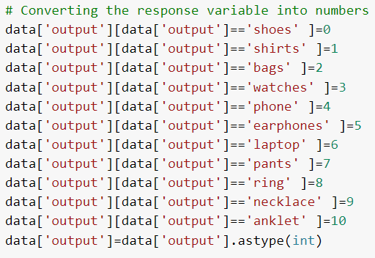

The data is split into train and test. A small training size is considered to avoid Kernel crash. This is followed by Normalizing the pixel values to 0 and 1.

**Model Compilation:**

Convolutional Neural Network model is used for Image Classification. The cnn model consists of many hidden layers. ReLU (Rectified Linear) activation function is used in the model to prevent the exponential growth in the computation required to operate the neural network. ReLU is a linear function that will output the input directly if it is positive, otherwise, it will output zero.

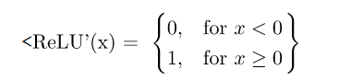

ReLU also prevents the emergence of the so-called “vanishing-gradient” problem, which is common when using sigmoidal functions.

Another typical characteristic of CNN is a Dropout Layer. This layer acts as a mask that nullifies the contribution of some neurons towards the next layer and leaves the others neurons. The Dropout Layer is applied to the hidden layer, in which it nullifies some hidden neurons.

The overfitting on the training data of the can be overcome by using the Dropout Layer.

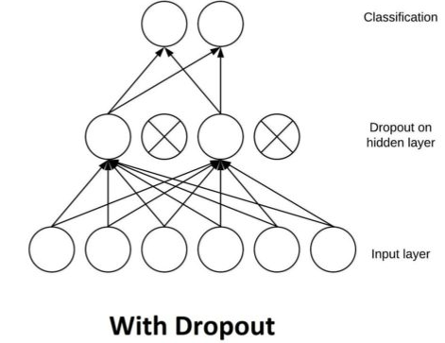

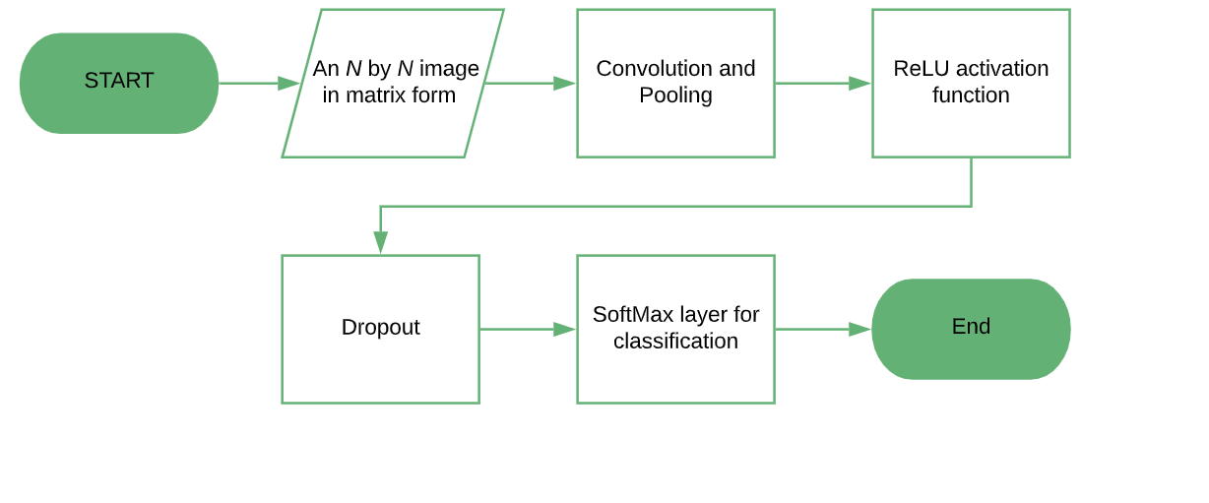

**Classification Output:**

A function is created which picks the random images from the dataset and identifies the class to which the product belongs.

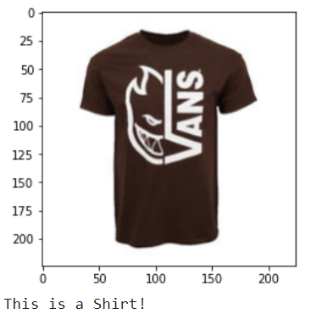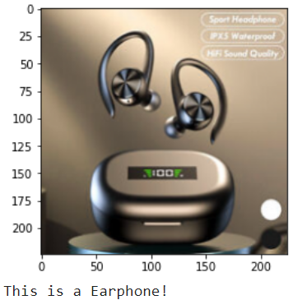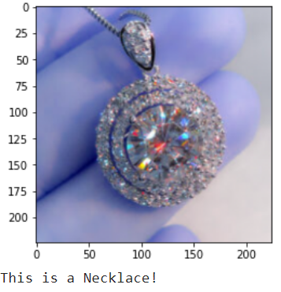

## RECOMMENDATIONS:

The next part of the project deals with recommending the most suitable products to users based on the current selection and choice of the product. The goal of the project is to suggest the best products to consumers based on their current product preferences and selection. The model relies on the fact that multiple features can be extracted from images and text to be used for similarity computation.

The recommendation engine built for the project is a content-based method. In a content-based method, the product features are obtained to recommend other similar products based on product attributes.

The two types of Recommendation Engines are:

* Image Based Recommendation Engine
* Text Based Recommendation Engine

## TEXT BASED RECOMMENDATION SYSTEM:

The objective here is to recommend N products based on product title.

In text-based recommendation, Sklearn’s metrics are used to compute the cosine similarities between the text feature (title, title + brand) to make product recommendations.

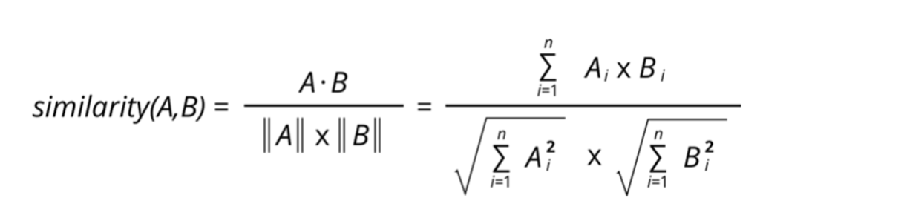

The weighted average formula is used to combine the separate cosine similarity scores with the weights of each type to produce a cosine similarity score for the product title and brand method. Then, based on the estimated cosine similarity listed in descending order, products were suggested. The recommended product title (or title + brand) is more semantically comparable to the input title the higher the cosine similarity.

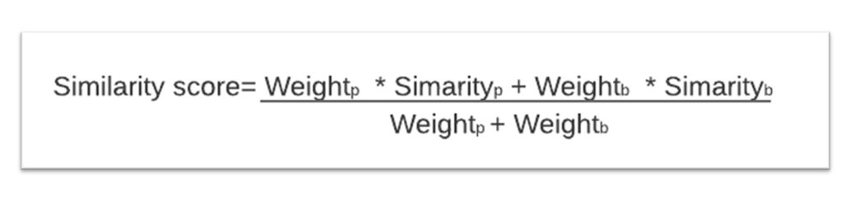

The first approach of the text-based recommendation system is to convert the text to Bag of Words with the help of CountVectorizer in Sklearn library. The stop words are removed, and the text is converted to lowercase.

The cosine similarity score between the product titles is obtained by using Sklearn’s metrics.

Finally, the recommendation engine is built, and a function is created that takes the Product ID and returns N recommendations. The results are obtained based on similarity score and arranged in descending order of similarity scores.

**Output :**

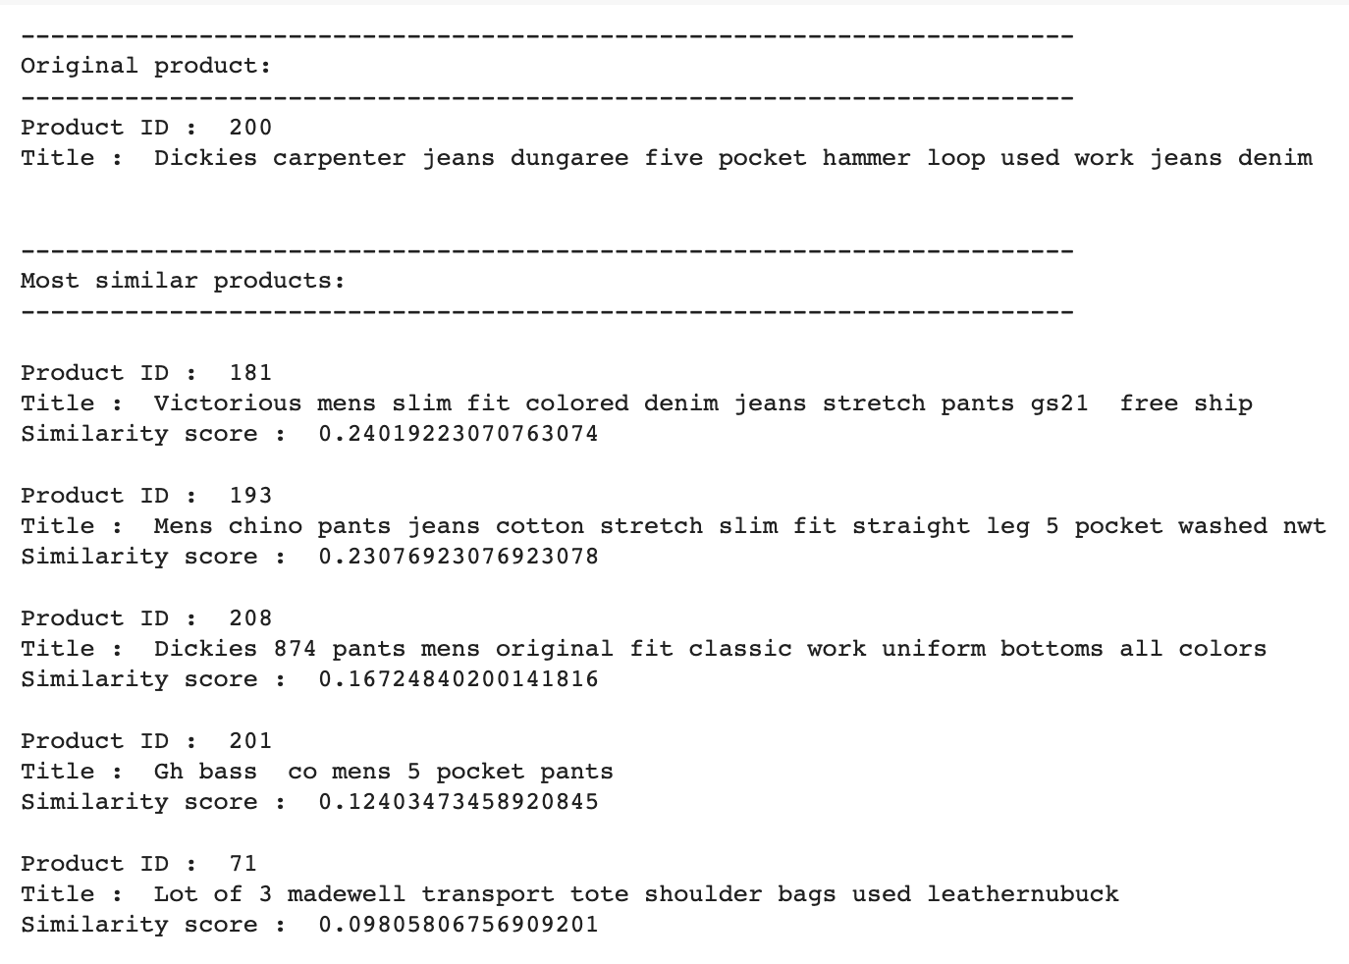

## IMAGE BASED RECOMMENDATION SYSTEM:

In image-based recommendation, the objective is to recommend N products based on images of the product. Firstly, the linear feature vectors are extracted from the images using a pre-trained model **VGG16**. The final output layer is removed the pre- trained model is not intended for classification.

In the next step, the output of the convolutional layer is pooled and reduced using global average pooling layer

Followed by a flattening layer, to get linear feature vector for the image.

**Cosine Similarity:**

The next step is to compute the cosine similarity scores between the image features. Based on the computed cosine similarity ranked in descending order, images are suggested. The recommended image is more semantically comparable to the input image when the cosine similarity is higher.

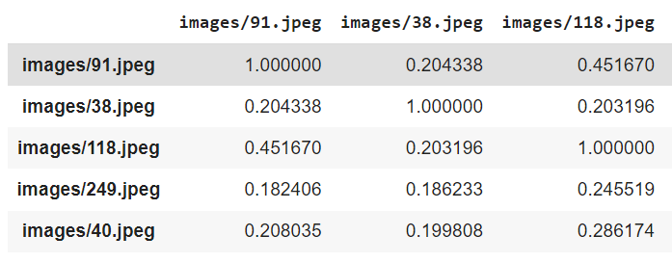

**Output :**

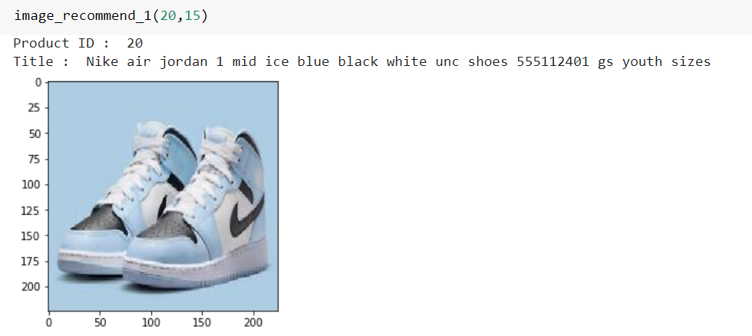

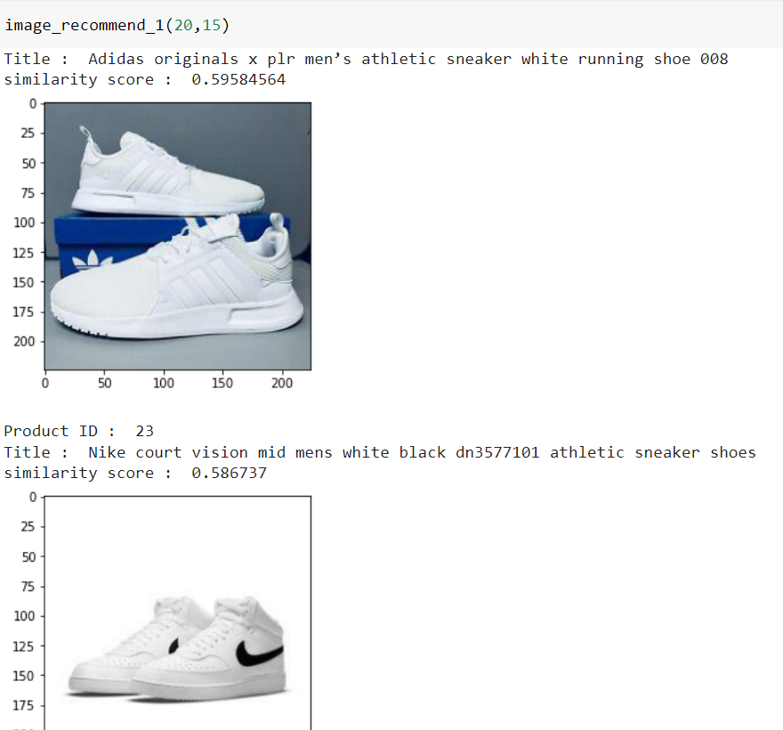

**CONNECTING GOOGLE COLAB TO AN AMAZON EC2 INSTANCE:**

Google Colab is a free Jupyter-based notebook environment that runs on google cloud’s servers, which allows users to leverage hardware (CPU, GPU and TPU) provided by Google. The latter two are particularly useful for data scientists and machine learning engineers. Another benefit of using Colab is that it provides access to Google Drive, which can be mounted and accessed via the file explorer. Colab also includes pre-installed deep learning libraries such as TensorFlow and Keras.

Google Colab includes a 12GB NVIDIA Tesla K80 GPU with an Nvidia compute capability of 3.7 that can be used continuously for up to 12 hours. While this is excellent for experimenting and prototyping, it quickly becomes limited when working with large datasets and/or larger networks.

The idea is to integrate Google Colab with AWS EC2 instance so that code can run on top of the EC2 instance runtime. Because Jupyter notebooks are a tool for exploration and not for production. Connecting an external runtime to Colab simply allows one to keep the Colab interface while using GPU acceleration other than what Colab provides by default.

**Steps for Integration:**

The integration of Google Colab and AWS EC2 instance is based on the following steps:

**Step 1:** Log into the AWS management console.

**Step 2:** Click on Services on the top left corner and select EC2.

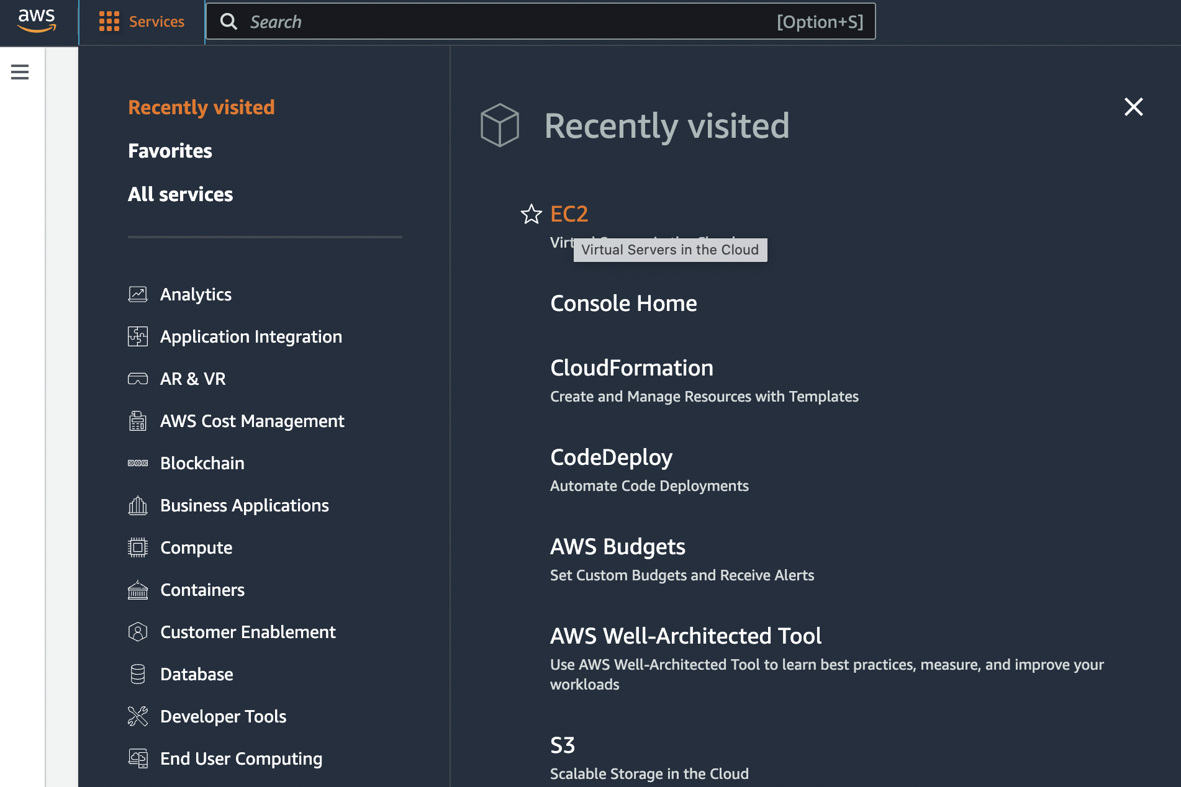

**Step 3:** Select Instances in the left pane, and then Launch Instance.

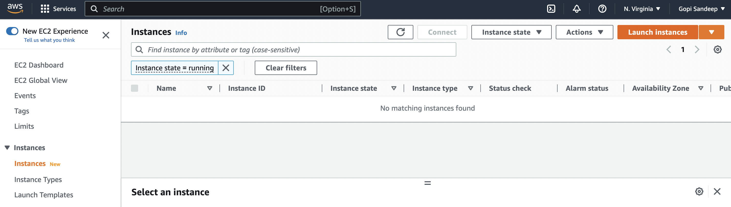

**Step 4:** Choose the image type. This determines the OS and software versions that’ll come preinstalled. Here we choose an Ubuntu 18.04 installation with TensorFlow 2.4.1 as well as CUDA installations.

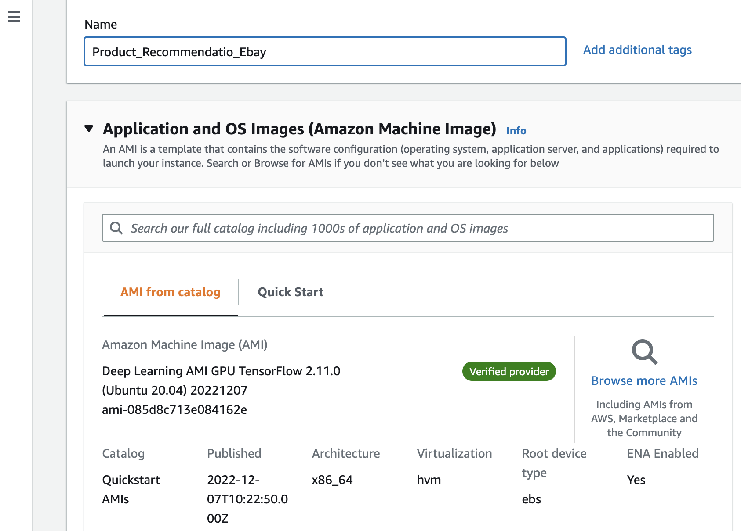

**Step 5:** Next, we choose the instance type. This will determine the type of hardware we get. We‘ll be selecting a P3.2xlarge instance. This includes a single Nvidia V100 GPU, 8 vCPUs, and 61GB of RAM.

**Step 6:** You may select “Configure Instance Details” if you wish to set additional details like storage and network options. To keep the default, select “Review and Launch”.

**Step 7:** Choose either an existing key pair or create a new one. This will serve as the authentication to log on to the server. If a new one is created, a file will be downloaded to your local computer.

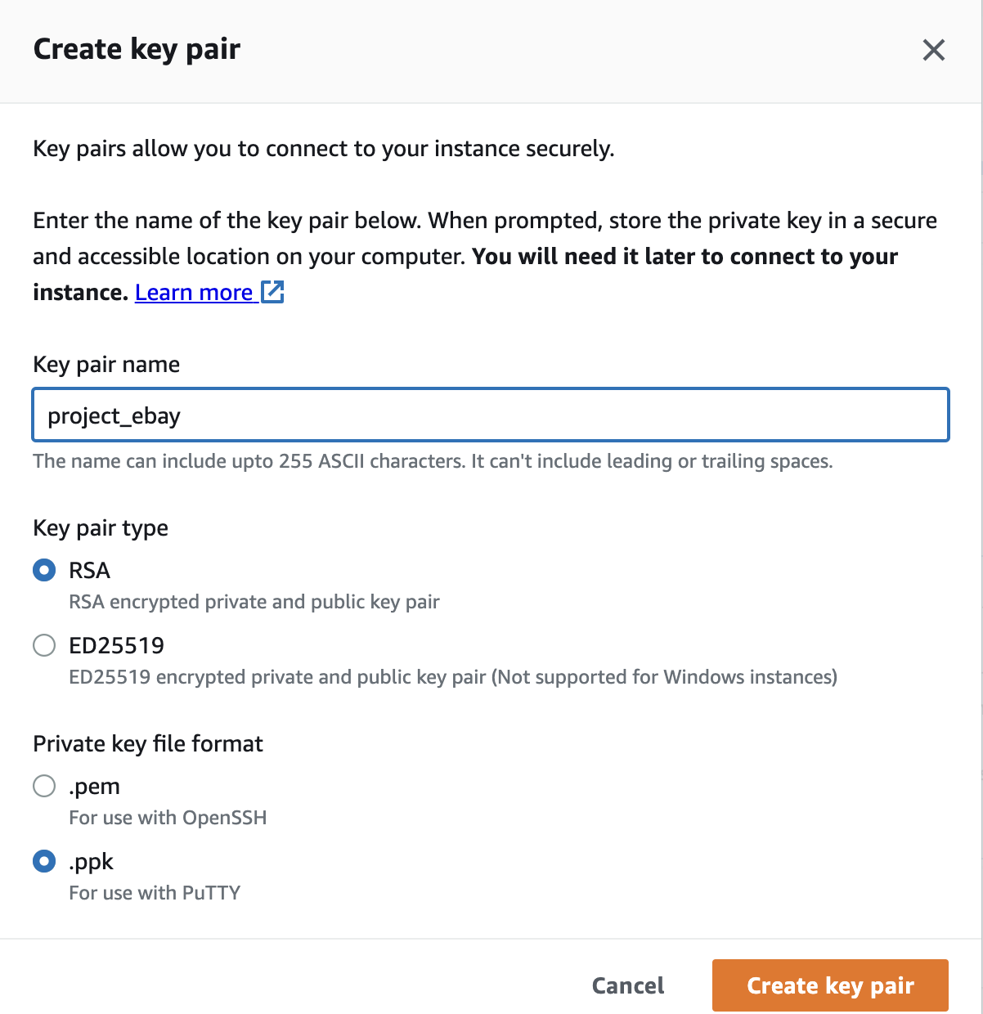

**Step 8:** Review details and click Launch.

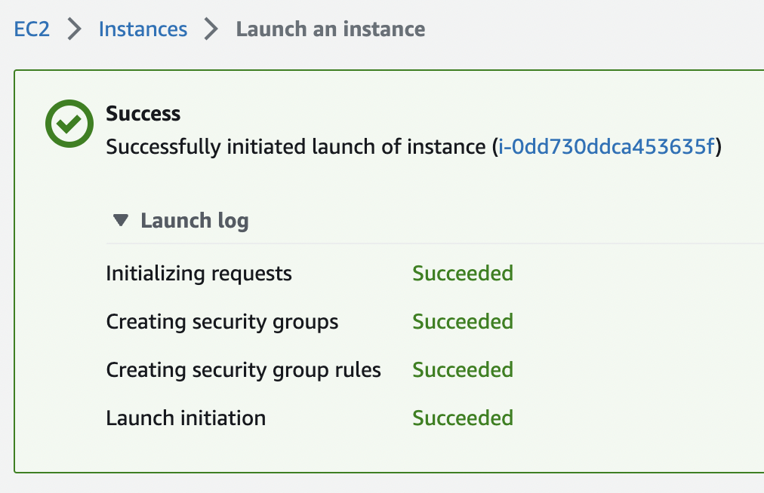

**Step 9:** Go back to the Instance Dashboard by clicking Instance on the left pane. This should list all instances including the one just created. Wait for the created instance to look like below with the instance state displaying “running” and status check “2/2 checks passed”. This means the instance is now running.

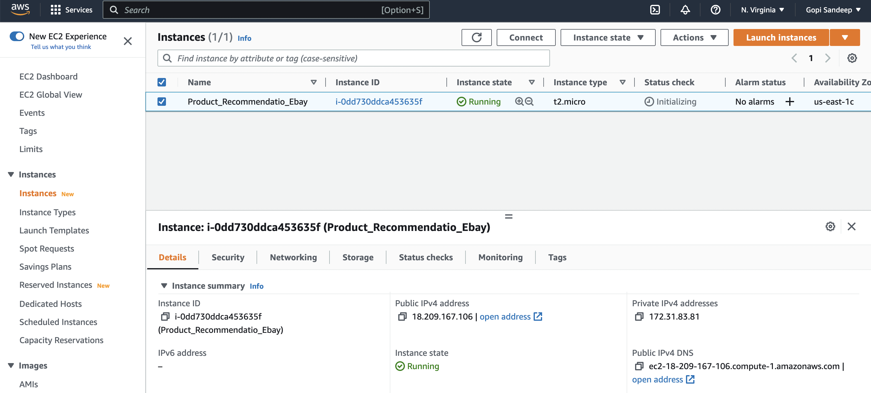

**Connect via SSH**

Click on the SSH client tab to see the ssh login details for the instance.

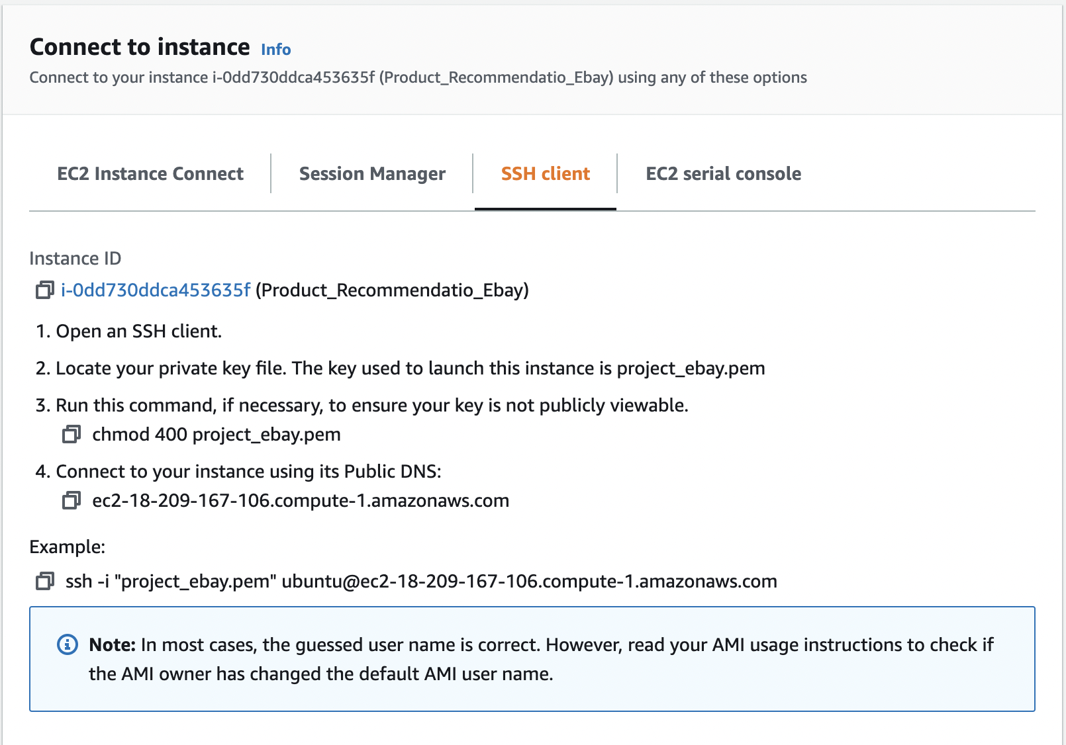

**SSH Details**

Putty SSH client has been used to login to the instance. The main reason using Putty is to set up SSH Tunneling. This is required in order connect Colab to the EC2 runtime.

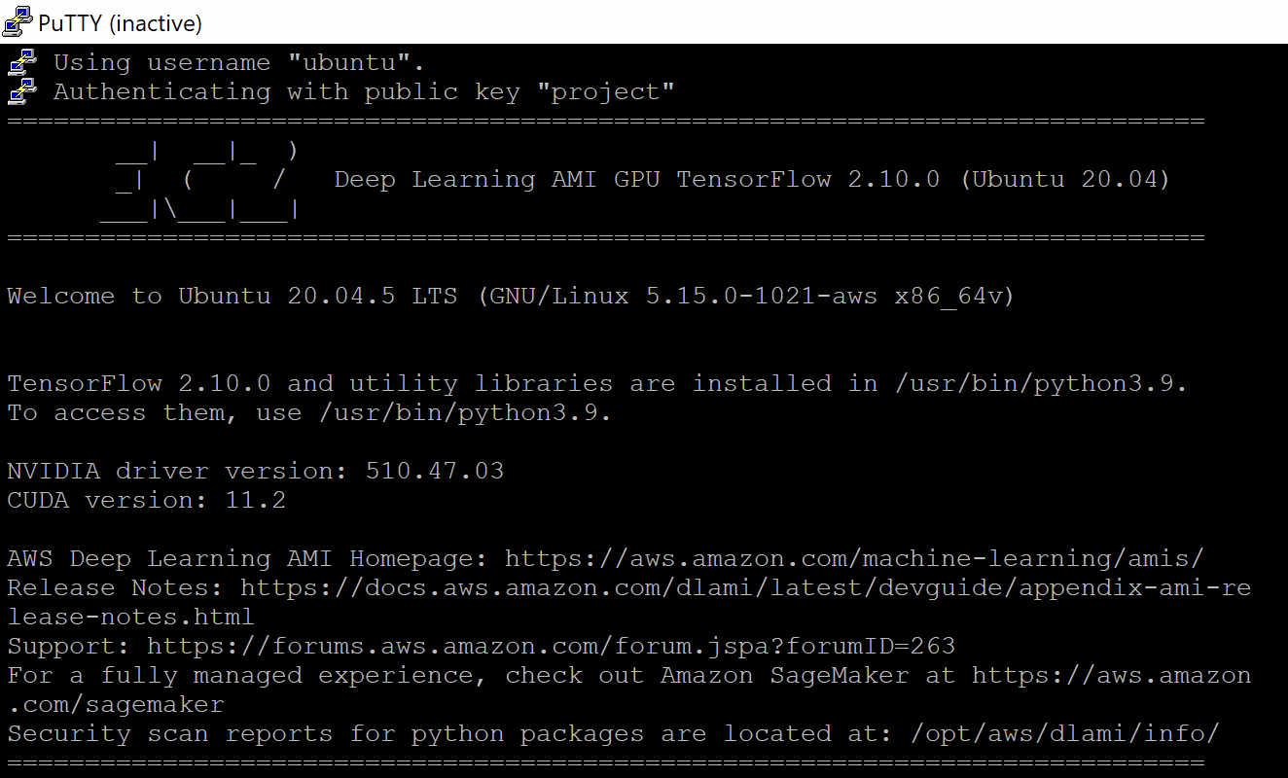

The jupyter_http_over_w extension authored by Google Colab needs to be installed next to allow connection to Colab.

Run the commands below in the command line:

pip install jupyter_http_over_ws

jupyter serverextension enable — py jupyter_http_over_ws

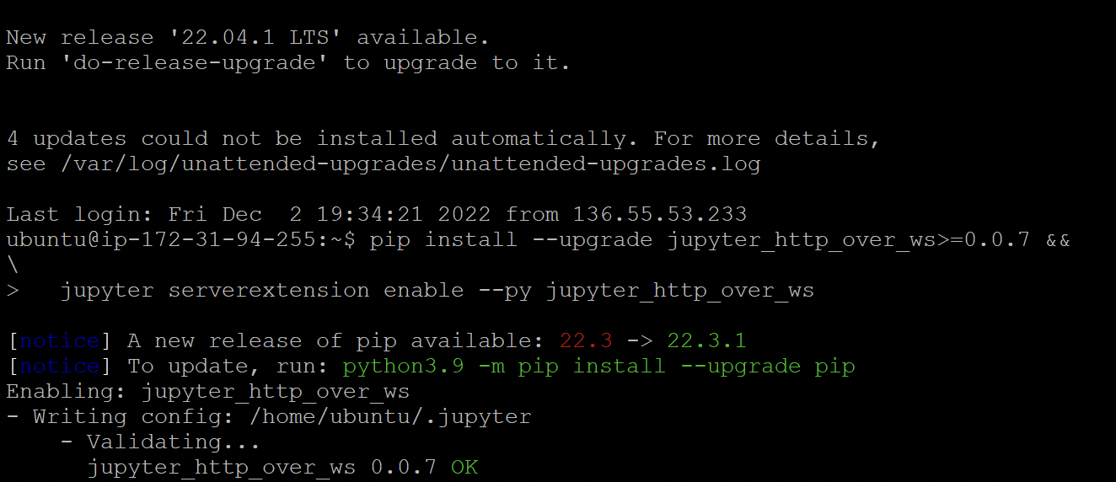

Use the command below to start the Jupyter Notebook service on the EC2 instance:

jupyter notebook \

— NotebookApp.allow_origin=’https://colab.research.google.com' \

— port=8888 \

— NotebookApp.port_retries=0

— NotebookApp.disable_check_xsrf=true”

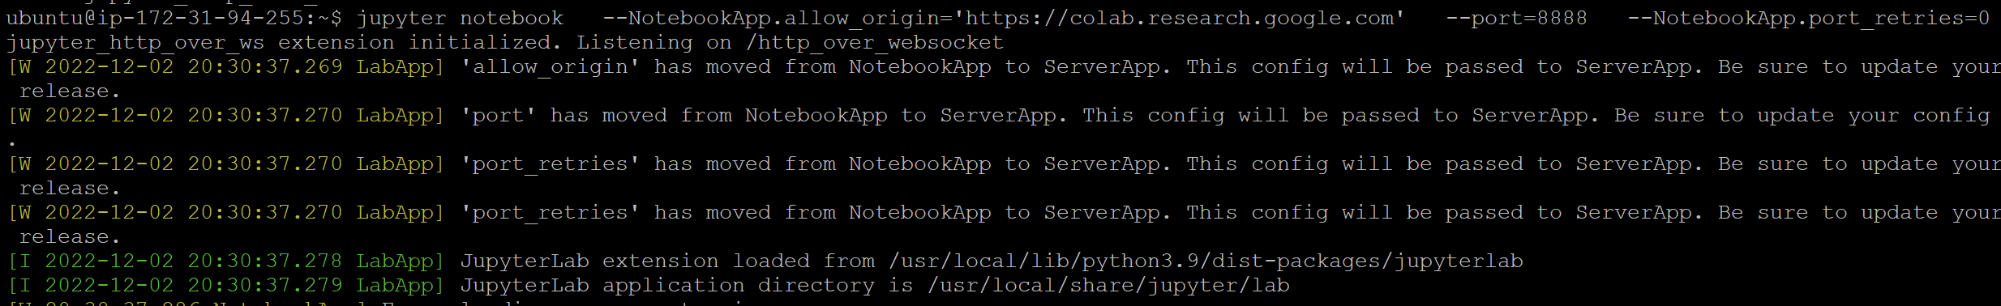

Specify the port 8888 as the same port specified during the SSH tunneling configuration.

If all goes well, an IP address will be obtained. The address should be copied as it would be needed in the next step.

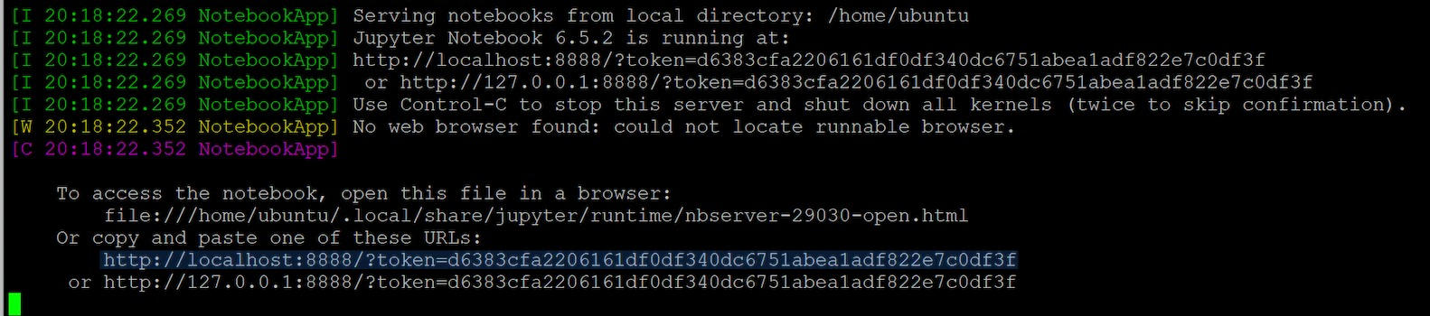

Open Google Colab, in the top right-hand corner, select Connect to local runtime.

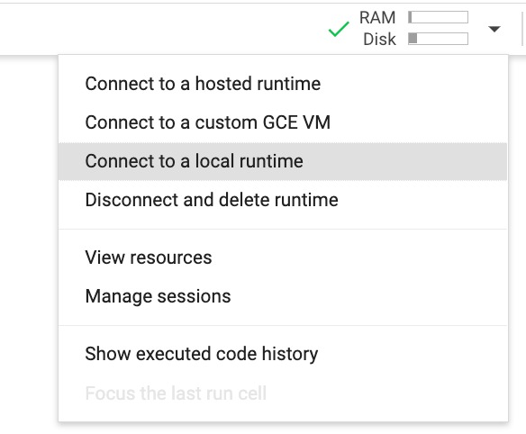

Copy the IP address from the terminal here and click Connect.

The result should look like this. Notice the “Local” next to Connected. This means Colab is connected to a runtime other than the Colab default. We also run some tests to confirm GPU is detected.

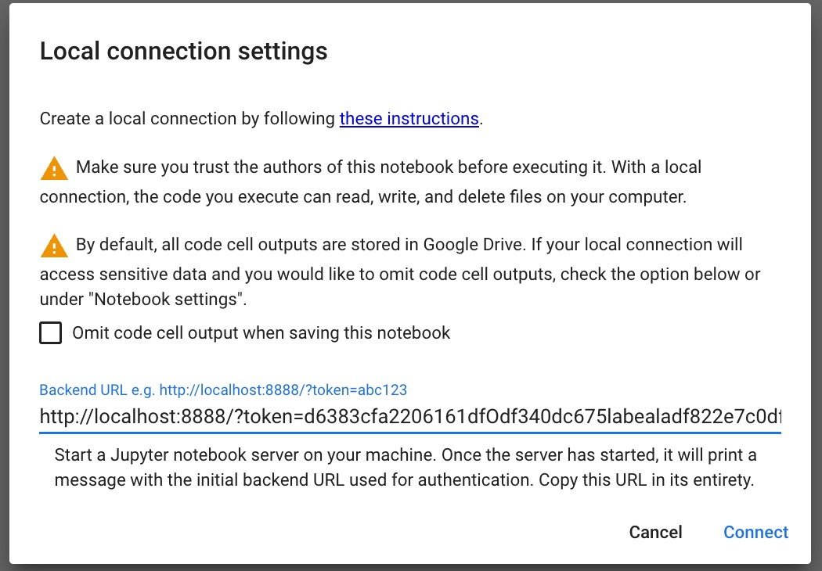

The AWS instance type p3.2xlarge incurs extra costs for GPU runtime allocation and hence an alternative way to deploy the code via Azure DevOps release pipeline with integration with GitHub.

**AZURE DEVOPS:**

Azure DevOps is used for deployment of the project. DevOps is an organizational approach that enables faster development of applications and easier maintenance of existing deployments.

Azure DevOps has Dashboard Control, Enhanced Source Control and Cloud hosted Services.

**Multi-Cloud:**

Multi-cloud refers to the use of more than one cloud service (multiple cloud services) from two or more vendors. Many companies implement multi-cloud strategy to distribute computing resources for different services they provide to minimize the risk of downtime and data loss.

**Advantages of Multi-Cloud:**

* Drives Innovation
* Avoids lock-ins with one vendor
* Better Resilience

**Steps for Deployment:**

The release pipeline is built based on the following steps:

**Step 1:** The code from Colab (source code) is stored in GitHub Repository.

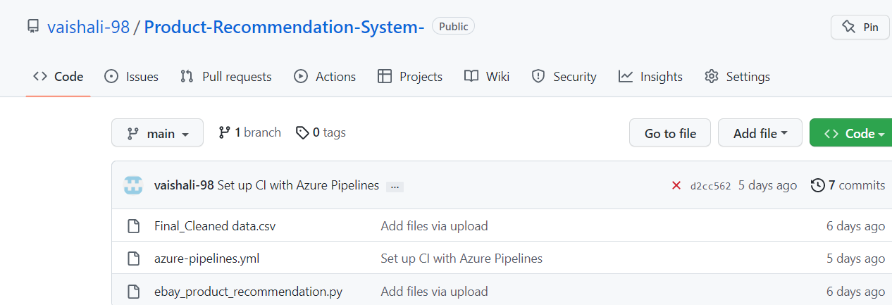

**Step 2:** The Artifact for the release pipeline is obtained from GitHub repository.

**Step 3:** The **dev** environment is created for creating the release pipeline.

**Step 4:** An empty job is created for Stage 1.

**Step 5:** An **agentless job** task to Delay the deployment for a minute is added along with another agentless job to send email to the other team members when the deployment is scheduled so that the other team members do not deploy their code.

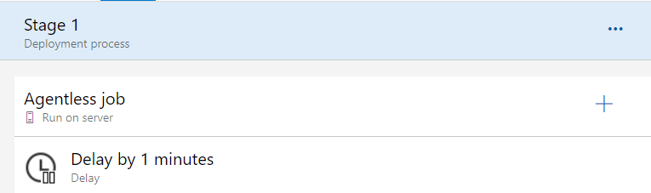

**Step 6:** An empty job is created for Stage 2.

**Step 7:** An **agent job** task is created to copy the files from the source to the destination. Another agent job task is created to trigger the deployment manually.

**Step 8:** The release pipeline is created, and Stage 1 and Stage 2 are deployed successfully.

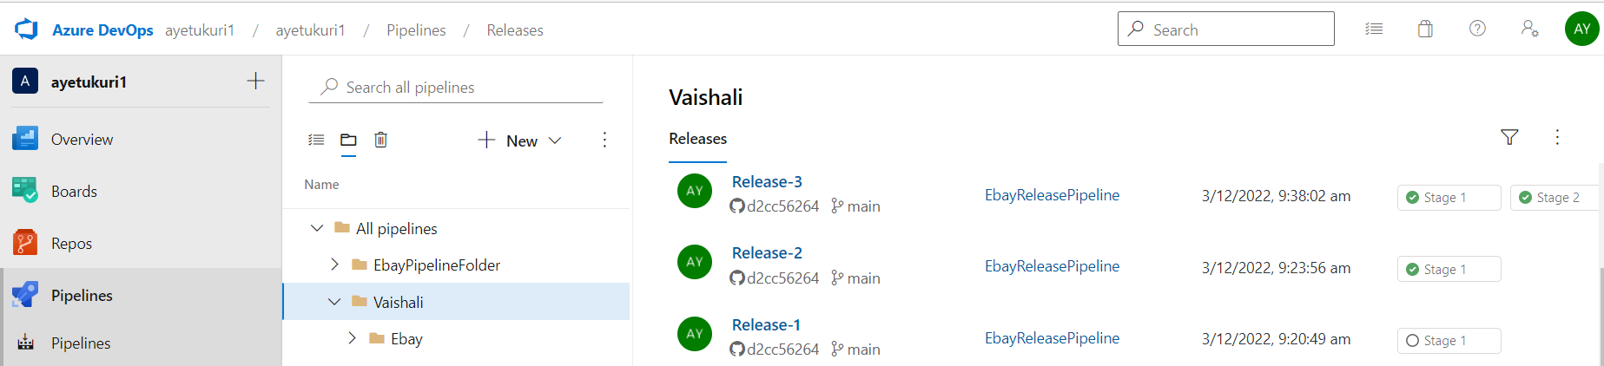

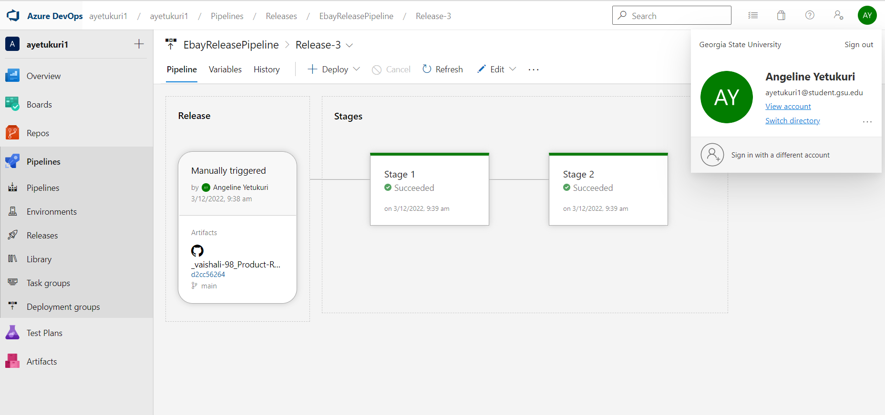

## KEY PERFORMANCE INDICATORS (KPI):

**Customer Retention Rate:** It is one of the important KPI’s as it is important to retain the customer by recommending good products to the customer and analyze how often the customer is satisfied with the product and recommendation.

**Annual Repurchase Rate:** This KPI talks about the customer annual spending the products on a particular website. With this we can recommend the products to the customer based on price of the product.

**Conversion Rate:** It is the percentage of visitors who completed a conversion. This central KPI measures the performance of the campaigns and landing pages.

## 

## CHALLENGES:

* **Parsing data from eBay website:** We must be careful when parsing the data as it is important to extract the data that satisfies all the data principles.
* **AWS EC2 and Google Colab integration:** The integration with EC2 instance and Google Colab is challenging due to the runtime availability and compute units are at higher price range for p3 instance types.
* **Scalability:** As we are moving the data to and fro to different tools it is important to keep the data by maintaining the scalability.
* **Changing trends:** We also need to consider the changes in the trends, when recommending the products to the customer.
* **New item introduction:** When a new item is introduced in the market it is important to consider the product when recommending to the customer.

## FUTURE WORK:

## Once recommendation systems are built, we are planning to compare image based and text based recommendation systems results based on similarity score.

## We want to test other recommendation engine methods like Collaborative filtering method.

## We plant to deploy the image classification and recommendation engine on a web app using Flask.

## REFERENCES:

* Reference 1:

<https://www.kaggle.com/code/shawamar/product-recommendation-system-for-e-commerce>

* Reference 2:

<https://docs.aws.amazon.com/>

* Reference 3:

<https://www.parsehub.com/intro>